Slide 1

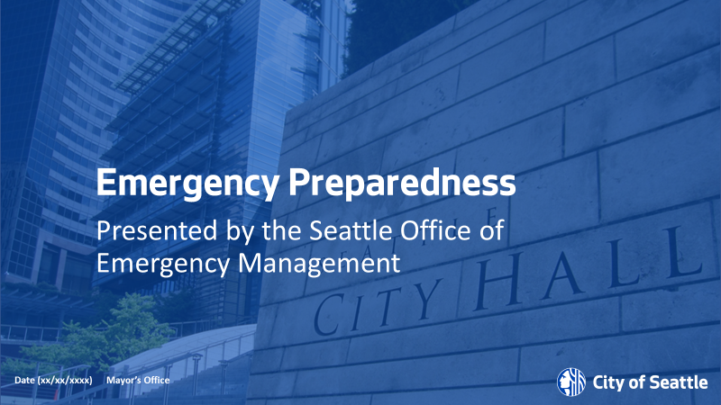

**Activity 1**: Get to know your audience.

Thank everyone for being here.

Introduce yourself, who you are and what you do.

Have everyone introduce themselves.

**Introduce the topic to Audience**

Today we are going to talk about Disaster Preparedness in Washington State. Here in the Seattle area we are susceptible to many types of disasters. Both natural and human made. Of those the number one threat to the Seattle area is an Earthquake.

Slide 2

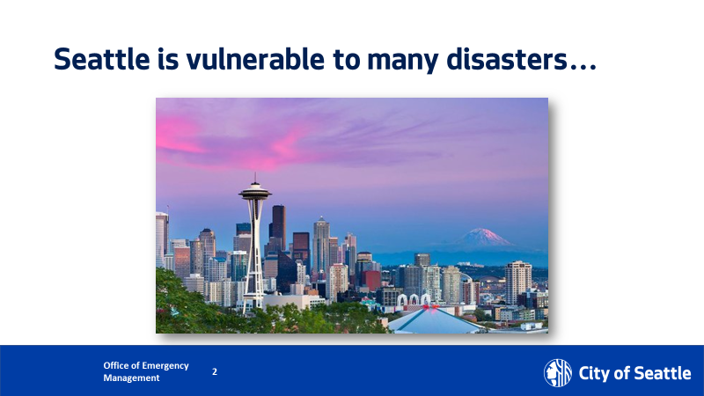

**Activity 2**: A question to ask the audience

Do we know, what is an earthquake? (allow time for participation)

**Answer:** A sudden and violent shaking of the ground, sometimes causing great destruction, as a result of movements within the earth’s crust or volcanic action.

**Activity 3**: Class interaction

 I am going to read some statements, and if you have experienced any of these disasters please raise your hands and keep them raised.

1. I have experienced an earthquake.
2. I have experienced a hurricane
3. I have experienced a drought
4. I have experienced a tsunami
5. I have experienced a snowstorm. lll

Now open your eyes and look around, we all have experienced some kind of major disaster. How prepared were we for thisdisaster? Will we be prepared for the next major disaster?

Slide 3

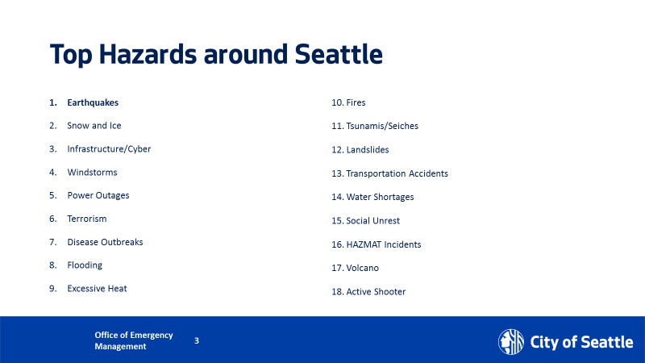

Here are some other types of disasters that may affect Seattle.

The foundation for the City of Seattle’s disaster planning and preparedness activities is informed by a document called SHIVA. The Seattle Hazard Identification and Vulnerability Analysis (SHIVA) identifies Seattle’s hazards and examines their consequences so we can make smart decisions about how best to prepare for them. The Office of Emergency Management is constantly collecting information from partners to update it. It is updated as needed but a major review occurs at least every four years.

Slide 4

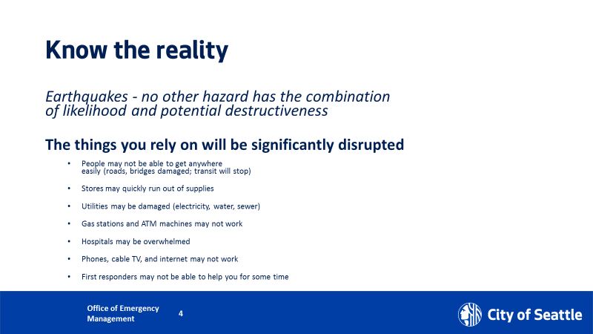

**Know the Reality:**

**The services you rely on will be significantly disrupted.**

* People may not be able to get places easily (roads, bridges damaged, transit will stop)
* Stores may quickly run out of supplies
* Utilities may be damaged (electricity, water, sewer)
* Gas stations and ATM machines may not work
* Hospitals may be overwhelmed
* Phones, cable TV, and internet may not work
* First responders may not be able to help you for some time

Slide 5

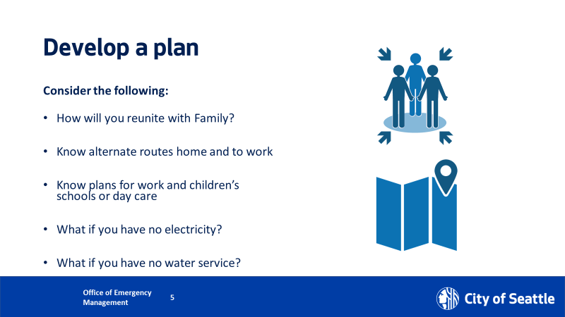

**Develop a plan:**

Start thinking about what are YOU going to do in the event of a major disaster.

* How will you reunite with family?
* Know alternate routes home and to work
* Know plans for work and children’s schools or day care
* What if you have no electricity?
* What if you have no water service?

**Questions to ask the audience**:

 Think about how many times you cross a bridge to get to and from home?

Think about how many times you turn on your faucet, open your refrigerator or flush the toilet**?**

Slide 6

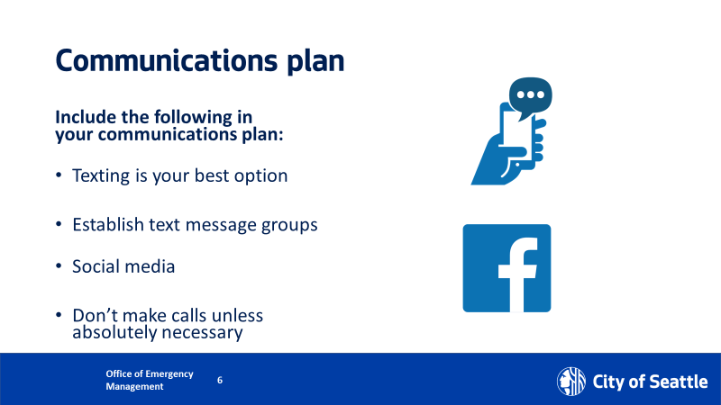

 Start think about how you are going to communicate to family if phone lines are down, or if there is no electricity (phone out of battery(etc.)

* Texting is your best option
* Establish text message groups
* Social media
* Don’t make calls unless absolutely necessary

Even if phone lines are up, there may be many individuals trying to make phone calls at the same time. Which will tie the phone lines, texting is the best option because it will continue to try to push through.

Landlines are even better because they are more likely to work in a disaster. Because their power is tied to the phone company, who may have a backup generator.

Social media is another tool of communication as well.

Have an out of area contact listed. After a major disaster again phone lines may be tied up because everyone in your area is trying to use the phone. You have a better chance reaching out to someone who lives in a different state

**Activity 5:** Ask the audience.

Raise your hands if you use Facebook or Twitter. This is a great tool to get on to let your family members and loved ones know you are okay.

**Activity 4:** Go over the insert in the infographics.

Slide 7

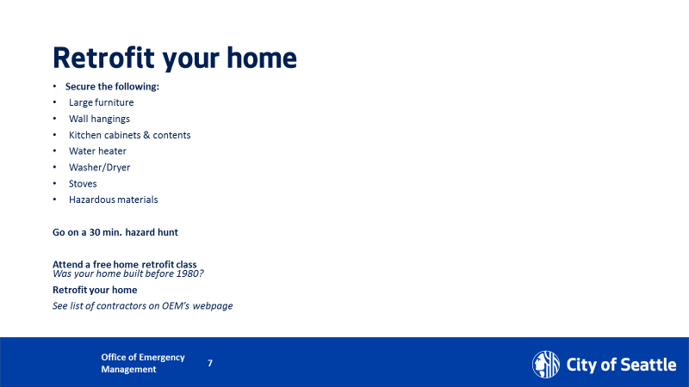

 Secure items in your home that might potentially fall on you, such as the following:

* Large furniture,
* Wall hangings
* Kitchen cabinets and contents
* Water heater
* Washer/Dryer
* Stoves
* Hazardous materials

Slide 8

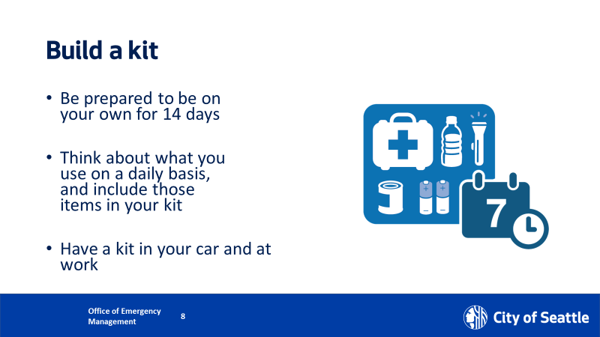

**#1 item – and most important:** Store emergency drinking water and stay hydrated – we all need it, no one lasts long without it. The golden rule is a gallon of water per person per day for two weeks.

**Items 2-4:** After that, focus on items that keep you warm, fed and dry, and have a safe light source Look around your home for: blankets, sturdy shoes, canned or dried foods, rain gear, plastic tarps, garbage bags, etc. Chances are you have all the basic items at home, right now. It’s just all over your home – do the gathering, have your kids do a scavenger hunt!

**Items 5:** Safe light source. Use flashlights (LED or otherwise), lanterns, hand-cranked, solar and/or battery-powered, or light sticks – no candles! This is earthquake country, aftershocks can tip over candles, and open flame will start fires. From there, customize your kit according to your own personal needs.

**Items 6-7:** Having small bills such as dollars bills is a great practice. Stores may not have internet access and cannot run your credit card or debit card. You need to be able to pay for things and may not be able to go to a bank or atm to get cash.

**Item 8: Documents:** Having copies of important documents saved with a relative or a friend that lives out of state is a good idea. Potential earthquakes and major disasters may destroy these documents and you may not have any way of identifying yourself for insurance or benefits.

**Potential Questions from the Audience:** Where will I store that water? I don’t have enough room in my house or apartment.

**Answer:** you can store less if you can go without bathing. This water includes drinking, cooking and bathing water. Also, if you have a water heater you can store less. A water heater can hold anywhere from up to 20 to 100 gallons of water.

Slide 9

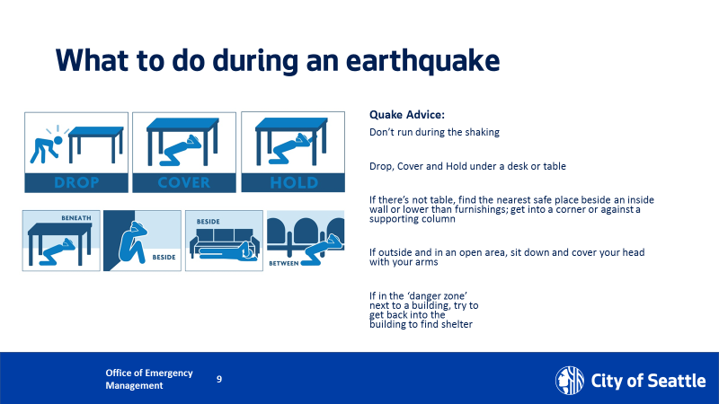

 During an earthquake, you should remember three actions to take: 1. DROP! COVER! HOLD!

Drop onto the floor, crawl under a table and cover your head. Hold onto the leg of the table.

If there is no table get onto a side of an inner, wall drop cover hold.

If you are in a wheelchair, get to an inner wall lock the wheelchair and cover your head.

**Demonstrate if possible:**



**Potential Question:** What about getting under a doorway?

**Answer:** Getting under a doorway is not much safer. You will get hit by the door and other flying objects.

Slide 10

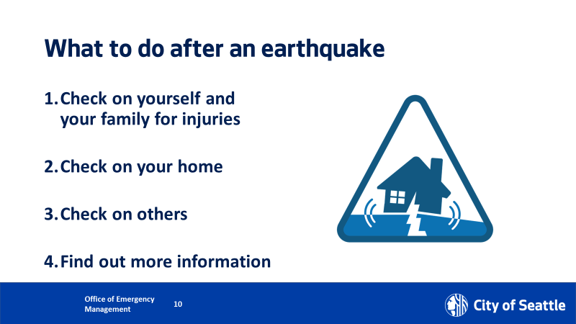

**What to do AFTER an earthquake?**

**After you make sure that you are safe:**

1. Check on your family for injuries
2. Check on your home (this includes controlling utilities and making sure you walk around building to inspect to see if there might be areas that need to be taped off that might fall and hurt neighbors.
3. Check on others
4. Find out more information

Slide 11

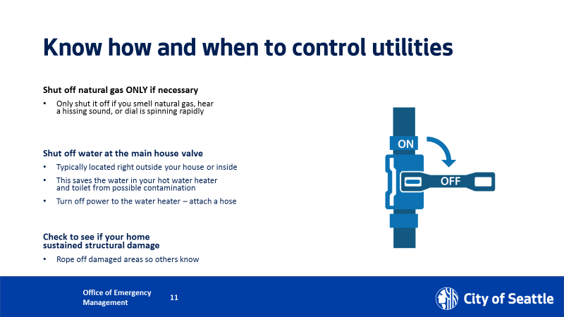

**Know How and When to control Utilities**

1. After earthquakes there potentially will be breaks in the gas pipes that may lead to leaking and explosions. Shut off natural gas ONLY if necessary…only shut it off if you smell natural gas, hear a hissing sound or a dial is spinning rapidly.
2. Shut off water at the main house valve. After earthquakes water pipes may break, you want to save the water that is running through your pipes by turning off the valve to the main pipes. That way you conserve the water already in the pipe and prevent it from flowing back into the main water line. Another source of water is the water heater in your home. Make sure to turn off the heating element of the hot water heater before draining it. A water heater that has been drained and the heating element is left on can become a fire hazard.

Slide 12

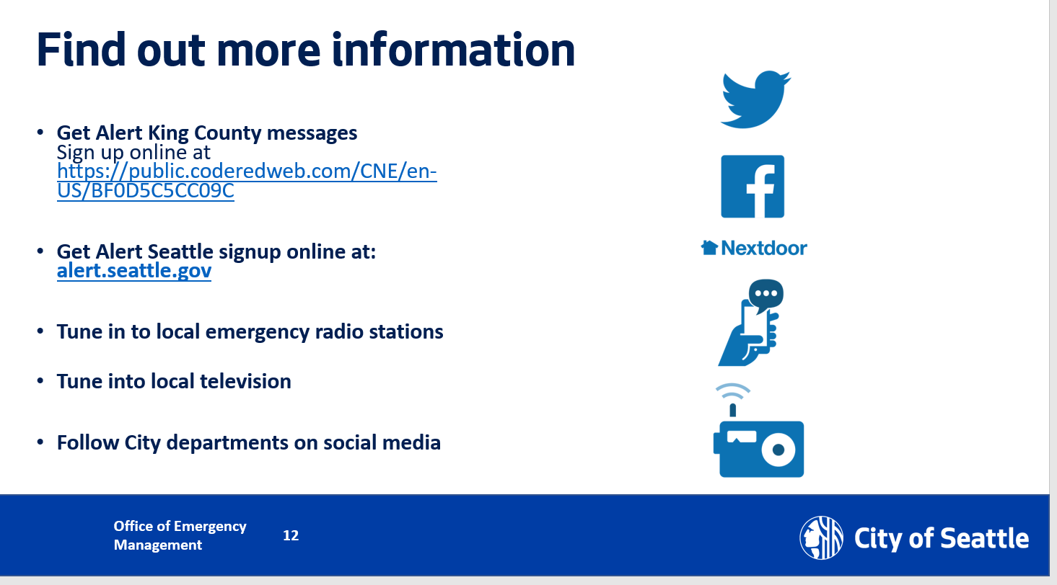

**Find out more information:**

Sign Up for Alert King County or Alert Seattle to check with your local jurisdiction about their Alert and Warning System

<https://public.coderedweb.com/CNE/en-US/BF0D5C5CC09C>

You can choose to get a phone call, email or text.

Tune into your local television

Follow your city departments on social media

Slide 13

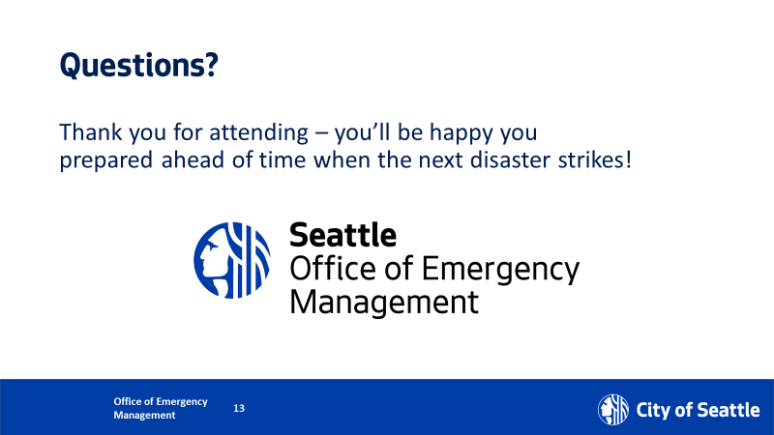

**Questions?**